**Practical No. 04**

**TITLE:** HELLO WORLD IN ANDROID STUDIO

**AIM:** TO STUDY HELLO WORLD IN ANDROID STUDIO

**APPARATUS:** ANDROID STUDIO

**THEORY:**

**Steps:**

1. **First Open Android Studio. Click on New Project Select Empty Activity.**

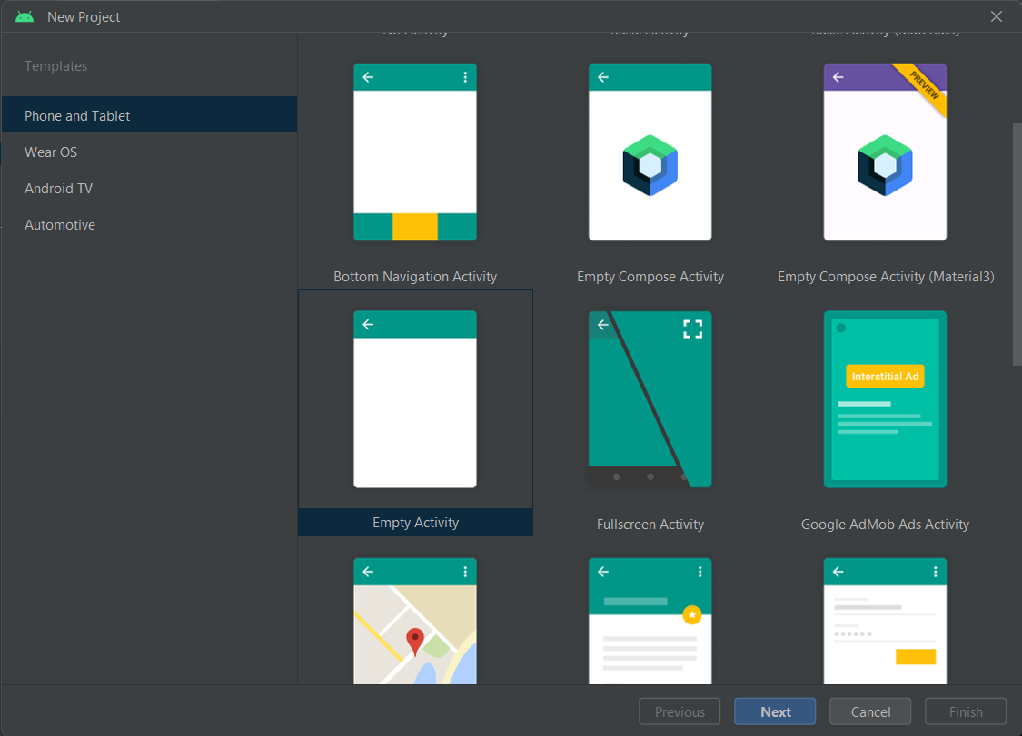

1. **Write Project name as “Hello World” then select language as “Java” and then click on finish.**

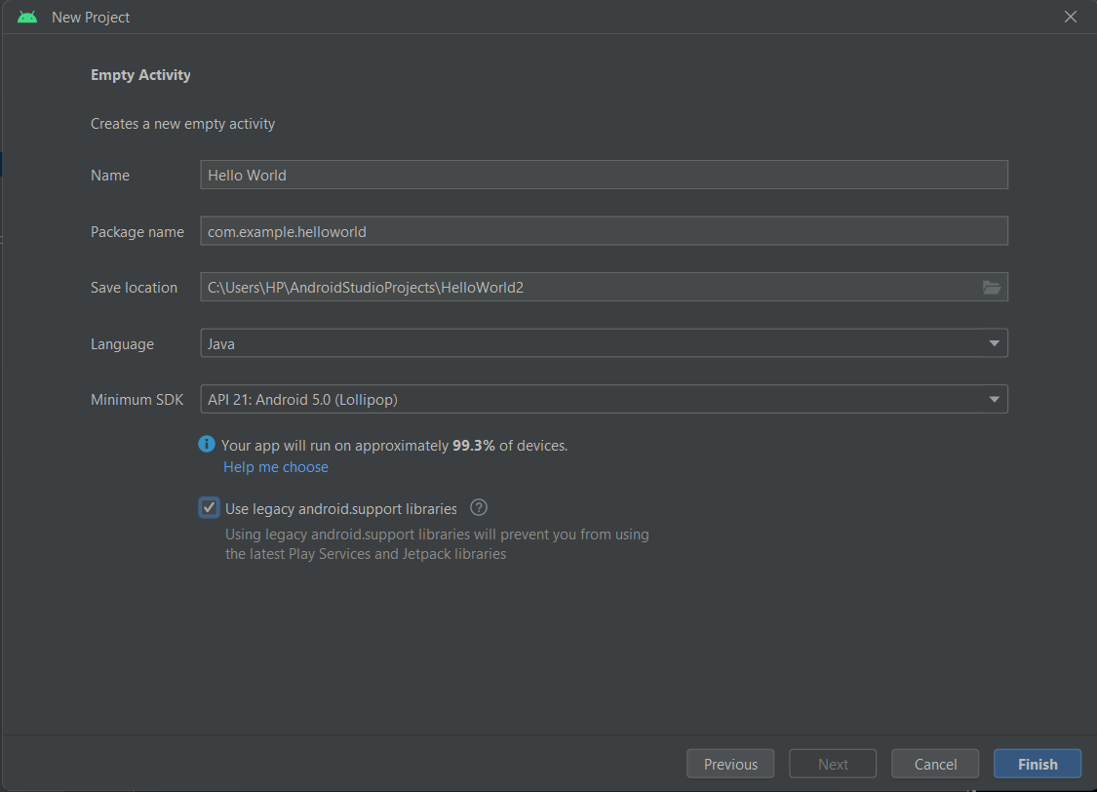

1. **activity_main.xml**

<?xml version="1.0" encoding="utf-8"?>

<android.support.constraint.ConstraintLayout xmlns:android="http://schemas.android.com/apk/res/android"

xmlns:app="http://schemas.android.com/apk/res-auto"

xmlns:tools="http://schemas.android.com/tools"

android:layout_width="match_parent"

android:layout_height="match_parent"

tools:context=".MainActivity">

<TextView

android:layout_width="wrap_content"

android:layout_height="wrap_content"

android:text="Hello World!"

app:layout_constraintBottom_toBottomOf="parent"

app:layout_constraintEnd_toEndOf="parent"

app:layout_constraintStart_toStartOf="parent"

app:layout_constraintTop_toTopOf="parent" />

</android.support.constraint.ConstraintLayout>

app:layout_constraintEnd_toEndOf="parent"

app:layout_constraintStart_toStartOf="parent"

app:layout_constraintTop_toTopOf="parent" />

</android.support.constraint.ConstraintLayout>

**Conclusion:** Thus we implemented the installation o

1. **MainActivity.java**

package com.example.helloworld;

import android.support.v7.app.AppCompatActivity;

import android.os.Bundle;

public class MainActivity extends AppCompatActivity {

@Override

protected void onCreate(Bundle savedInstanceState) {

super.onCreate(savedInstanceState);

setContentView(R.layout.activity_main);

}

}

1. **Project Files**

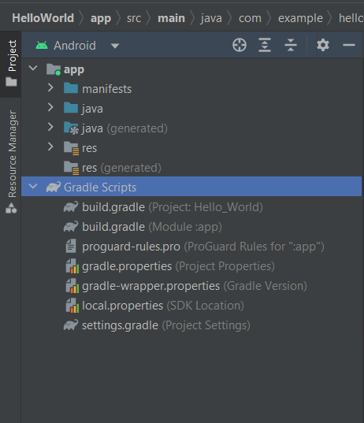

1. **Output on Emulator –**

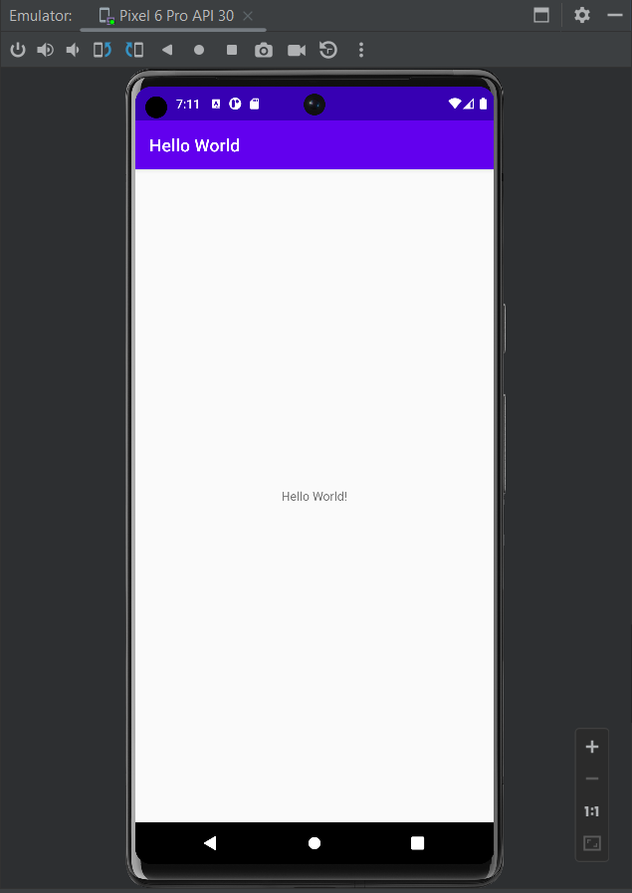

**Conclusion:** Thus we studied the implementation of Hello world on Android Studio.